Title
L. Chatellier^{1*}, A.Sciacchitano², B. van Oudheusden²
¹Affiliation, Address
²Affiliation, Address
*corresponding.author@domain.ext

Abstract
The HOMER workshop on Optical Metrology and Data Assimilation Applied to Aeroelastics (Figure 1) aims at gathering experts of various horizons to share on novel diagnostic and analysis techniques for Aeroelatics and Fluid-Structure Interactions studies.
As part of the Holistic Optical Metrology for Aero-Elastic Research H2020 project, the Workshop offers the opportunity to the fluid and solid mechanics, biomechanics, physics and mathematics communities to exchange on innovative methodologies and recent results.
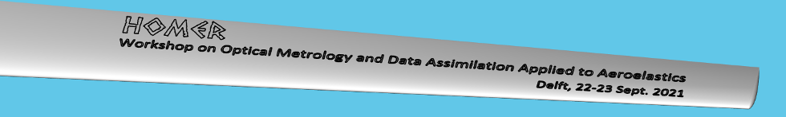
Figure 1: Website header image.
Acknowledgements
This project has received funding from the European Union’s Horizon 2020 research and innovation
programme under grant agreement No 769237 HOMER.
References

L. Chatellier, A.Sciacchitano, B. van Oudheusden, Abstract Template, Workshop on Optical Metrology and Data Assimilation Applied to Aeroelastics, Sept. 22-23, 2021 | TU Delft, NL & Online, 2021

